Extra Practice with Time: Using menos

To say “until” a certain time in Spanish, we use the formulas below:

Until 1:00 – Es la una menos (# minutes until 1) de la (mañana/ tarde/ noche)

Until any other time – Son las (hour) menos (# minutes until) de la (mañana/
tarde/ noche)

Let’s look at a few examples:

2:55pm – In English we could say this time two ways:
It’s two fifty five in the afternoon
It’s five minutes until three in the afternoon.

In Spanish we could say this time two ways also.
Son las dos y cincuenta y cinco de la tarde
Son las tres menos cinco de la tarde. (3:00 – 5 minutes)

Notice that when we use the “until” construction (in Spanish or English) we are really doing math! We round the time up to the next closest hour then subtract the actual number of minutes until that hour.
Step 1 : Round up to the next hour
Ex: 2:55 – we round up to 3:00 (Son las tres)
Step 2: Find out how many minutes there are between the two times.
Ex: Since there are 60 minutes in an hour and our clock says 2:55 we can subtract 55 from sixty (60 -55 = 5) to figure out the number of minutes until three. In this case there are 5.
Step 3: Say the time:
Ex: Since 5 minutes will pass until the clock actually says 3:00, we have to subtract that five minutes from 3:00. So in English we say five ‘til 3:00. In Spanish, we say 3:00 minus five. Son las tres menos cinco de la tarde.

Let’s look at it pictorially. -5 minutes

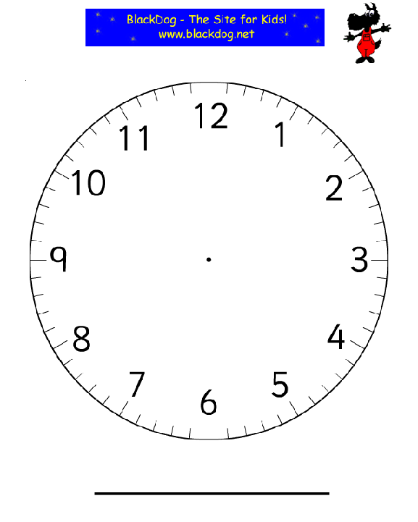

12:31 – 1:59 gets a bit trickier

Remember: When dealing with 1:00, you say “Es la” instead of “Son las”
For example: 12:45pm= Son las doce y cuarenta y cinco de la tarde
A quarter ‘til 1:00 = Es la una menos cuarto de la tarde.

1:50pm = Es la una y cincuenta de la tarde
Ten ‘til 2:00 = Son las dos menos diez

Whether you are saying “it’s one minus (so many minutes)” or “It’s one and (so many minutes), you have to use “Es la”.

Look at the first example

Look at the second example

Practicing Time with “menos”

Write out the following times using the “menos” construction.

12:39 pm ____________________________________________________________
5:46 am ____________________________________________________________
4: 54 pm ____________________________________________________________
9:38 am ____________________________________________________________
6:42 pm ____________________________________________________________
8:57 pm ____________________________________________________________
10:45 am ____________________________________________________________
3: 33 pm ____________________________________________________________
2:59 pm ____________________________________________________________
1: 40 pm ____________________________________________________________
7: 31 pm ____________________________________________________________
11: 50 am ____________________________________________________________
12: 55pm ____________________________________________________________
8: 35 am ____________________________________________________________
1: 49 pm ____________________________________________________________

Read the following times and write the digital form with am or pm on the line provided.

- Son las cuatro menos veinte y nueve de la tarde. ________________________
- Es la una menos diez y siete de la tarde ________________________
- Son las diez menos cuatro de la mañana ________________________
- Son las dos menos doce de la tarde ________________________
- Son las once menos cuarto de noche ________________________

Read the following times and re-write them using the “and” construction.
- Es la una menos veinte de la tarde. ____________________________________
- Son las dos menos once de la tarde ____________________________________
- Son las doce menos trece de la noche ____________________________________
- Son las ocho menos catorce de la manana________________________________

